Prototype and/or Diorama

*detailed diagram / plan is due at the end of class 12/2 or 12/3  *actual prototype / diorama due completed by the end of class Tuesday 12/8 | 4 | 3 | 2 | 1
 | Working prototype OR diorama | Non-working prototype OR diorama | Drawing of solution | No prototype, drawing or diorama

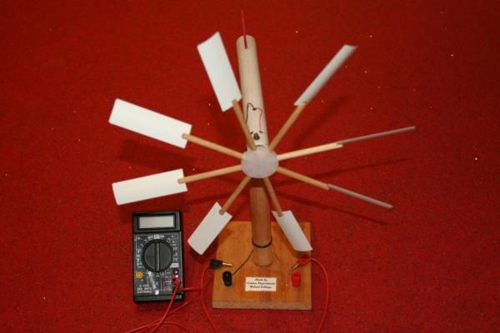
Prototype: a first or preliminary model of something, especially a machine, from which other forms are developed or copied
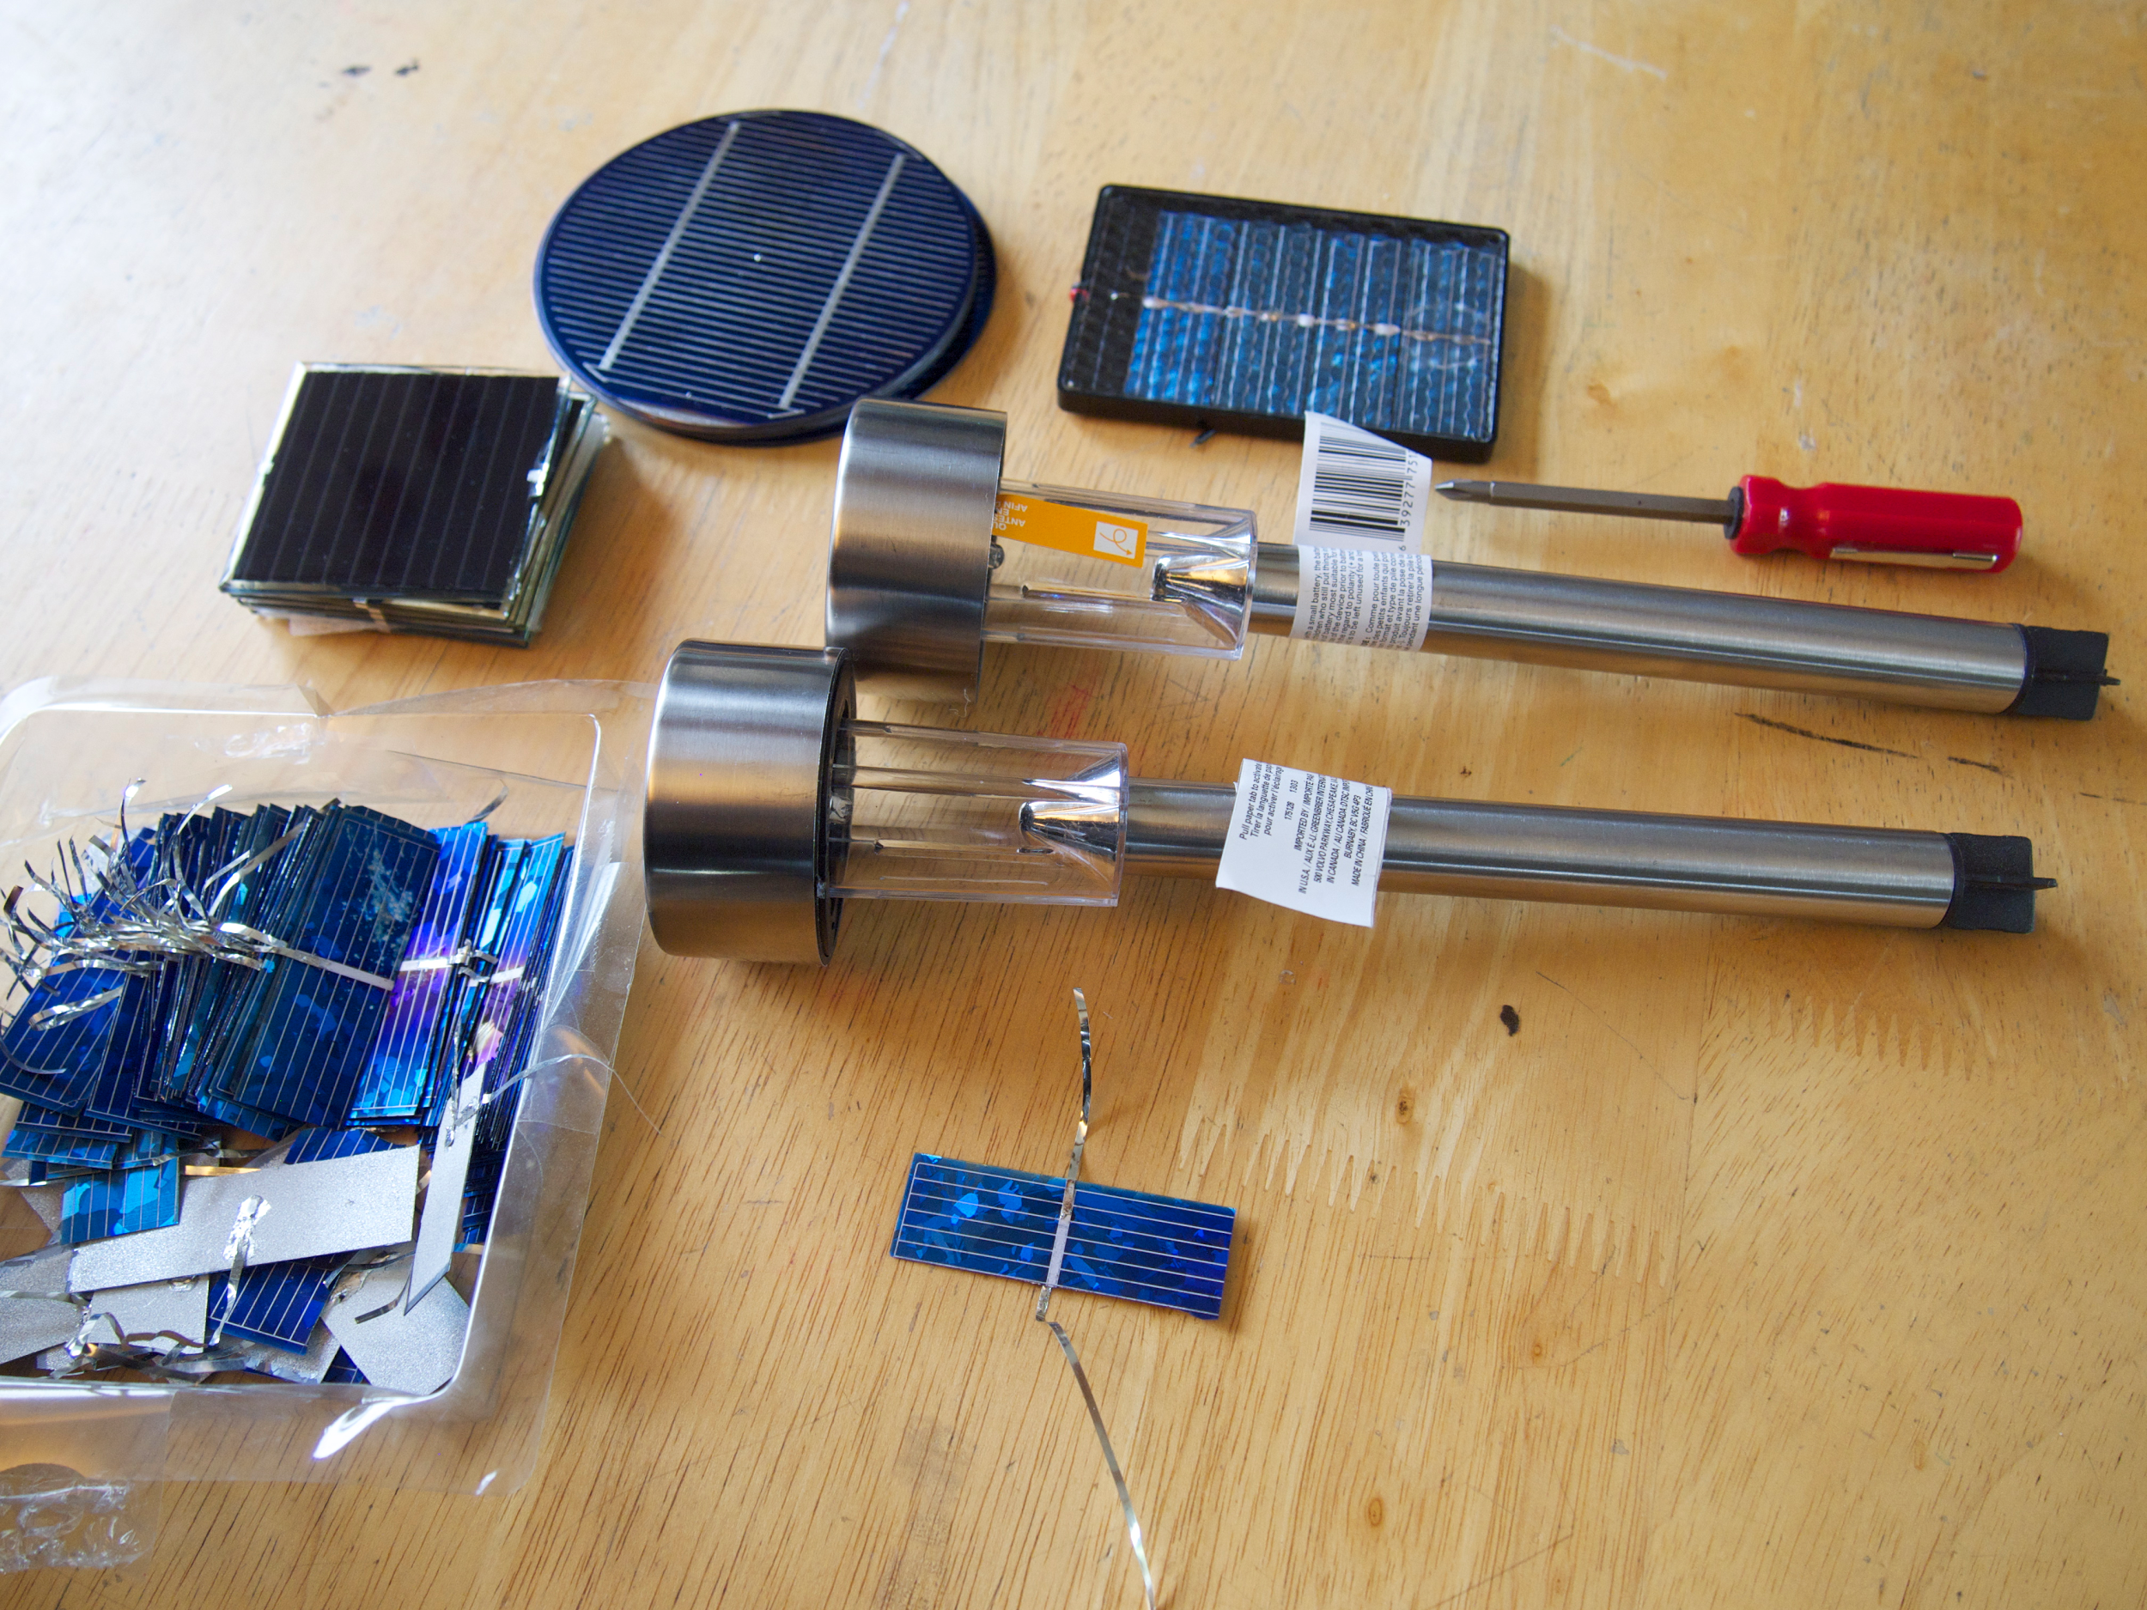

Diorama: a model representing a scene with three-dimensional figures, either in miniature or as a large-scale museum exhibit
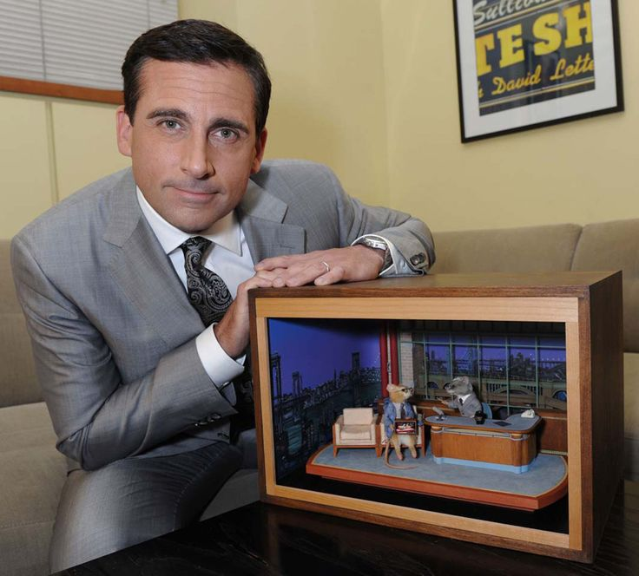
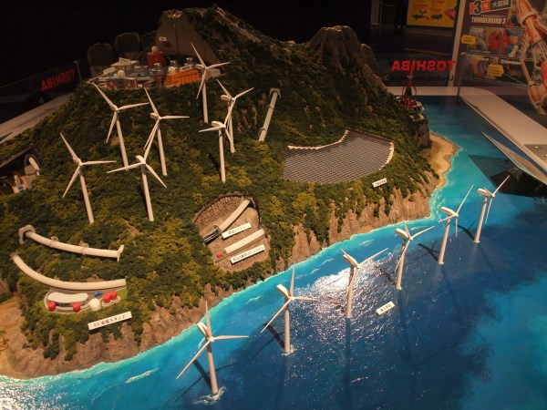
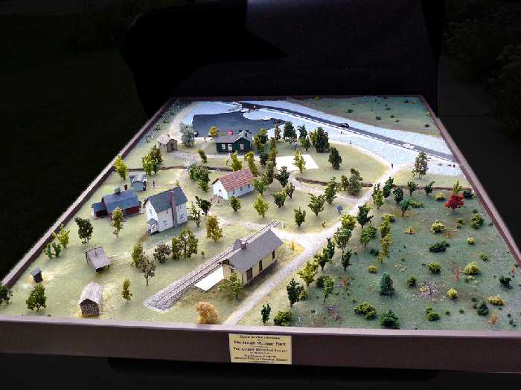

It would look really cool if you combine the two ideas. Make a diorama with a working prototype!
Today: Turn in a DETAILED diagram of your prototype / diorama AND a list of materials you need to create it.
Also work on your CER and remaining task list items.

